Lab: View/Edit Popups

Currently, users can add, remove, and edit contact interactions on the Interactions page in the Interactions list view panel. However, the editable list view panel on the page only exposes some of the Interaction entity fields. In this lab, you will extend how users can view and edit contact interactions using a popup location.

Requirements

This lab requires that you use TrainingApp 8.0, Guidewire Studio 8.0, and Chrome as your web browser. To view, edit, and delete various contacts, log in to TrainingApp as Alice Applegate. The default URL for TrainingApp is <http://localhost:8880/ab/ContactManager.do>. The login/password for Alice Applegate is aapplegate/gw.

1. Create a Popup

In this exercise, you will first create the Interactions Popup. The popup will all users to edit and view an interaction. Next, you will modify the InteractionsLV. You will configure a cell widget in the list view panel to navigate to the popup.

Tasks

1. Open Guidewire Studio for TrainingApp
2. From Studio, if your server is not already running, start the server using Debug 'Server'.
3. Review the Debug console for errors and verify that the application is running in the Debug console.
4. Create a popup location named InteractionPopup
5. In Project View, create the InteractionPopup in the traininglabs PCF folder.
6. Configure the popup to allow users to edit interaction objects that are passed from the InteractionsLV.
7. To the popup, add an inline detail view panel.
8. To the inline detail view panel, add editable widgets for the following Interaction_Ext entity fields:
   * Interaction Date
   * Initiated by Contact
   * Channel Type
   * Summary
   * User
   * Interaction Reason
9. Use your best judgment for field ordering, display keys, and input widget selection.
10. Modify the InteractionsLV
11. Modify the cell widget for the Reason field to be a navigable link to an editable Interactions popup.

Verification

1. Log in to TrainingApp
2. Log in as Alice Applegate.
3. Reload the PCF changes
4. In TrainingApp, reload the PCF file changes.
5. Edit the Interactions page for William Andy
6. Open the William Andy contact.
7. In the sidebar menu, click Interactions.
8. If you previous did not create an interaction, create at least one interaction now in the list view panel.
   * Click Edit then click Add
   * Enter a date, Reason, and select a user.
   * Click Update.
9. For an interaction row, click an interaction reason link.
10. Edit all editable fields in the Interaction Popup.
11. Click Update.

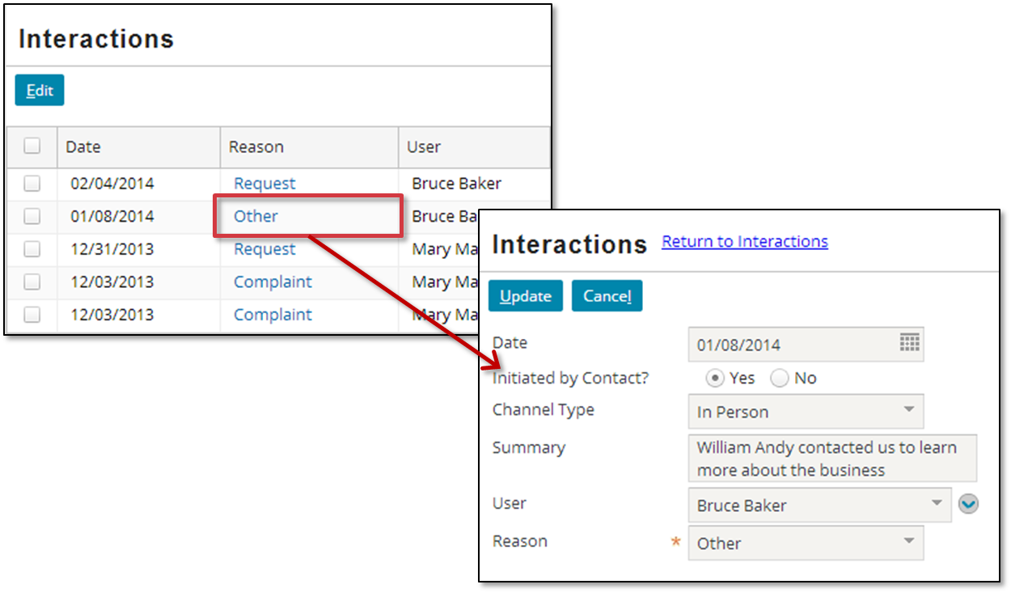

|  |  |
| --- | --- |
|  | Stop and ask your instructor to review your completed lab. |